OVERHEADS 1-7-2018
- “It is he who will go as a forerunner before Him in the Power of Elijah, TO TURN THE HEARTS OF THE FATHERS BACK TO THE CHILDREN,” Luke 1:17 NASB
The charge of the Spiritual Father
- “In the beginning was the Word and the Word was with God and the Word was God.” (Emphasis mine) John 1:1 NASB
“And the word became flesh, and dwelt among us, and we saw His glory.” John 1:14 NASB

- “Phillip said to Him, “Lord, show us the Father, and it will be enough for us.” Jesus said to him, “Have I been with you so long, and yet you have not come to know Me, Phillip? He who has seen Me has seen the Father” (Emphasis mine) John 14:8-10 NASB
“And His name will be called Wonderful Counselor, Mighty God, Eternal Father, Prince of Peace.” Isaiah 9:6 NASB
Jesus is God

- Michelangelo Finger of God
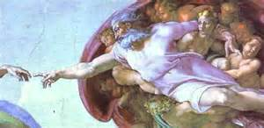

- Gary Larson
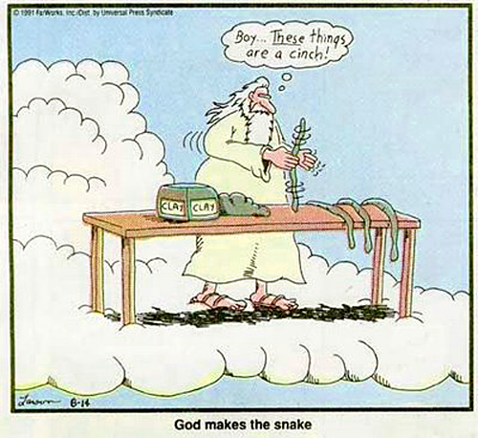
- Prince of Peace Painting by Akiane Kramairk
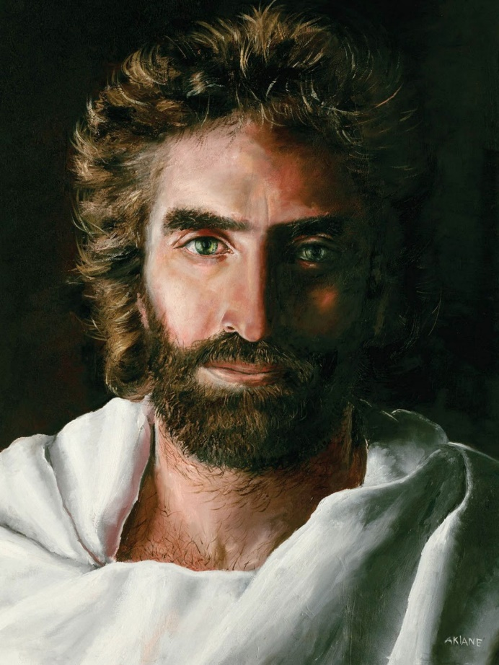

- “Truly ,truly I say to you, before Abraham was born, I am.” John 8:58 NASB
“My Father is working until now, I myself am working” John 5:17 NASB
God cannot get old. God is not retired.
- “Permit the children to come to Me; do not hinder them; for the kingdom of God belongs to such as these. Truly I say to you, whoever does not receive the kingdom of God like a child will not enter at all.” Mark 10:13-16 NASB
God loves and wants to be around children.

- “Straightening up, Jesus said to her, “woman, where are they? Did no one condemn you?” She said, “No one Lord.” And Jesus said, “I do not condemn you either. Go. From now on sin no more.”
God doesn’t want to get us in trouble, He wants to get us out of trouble.
- 1970 Pontiac Bonneville

- “…If you then being evil, know how to give good gifts to your children, how much more will your heavenly Father give the Holy Spirit to those who ask Him?” Luke 11:11-17 NASB
God loves us more than any earthly father because He has the capacity to.
- Jerry Jones

- “Beloved, let us love one another, for love is from God; and everyone who loves is born of God and knows God. The one who does not love does not know God, for God is love.” 1 John 4:7-8 NASB
A great stumbling block to our relationship with God our Heavenly Father is our flawed relationship with our own earthly fathers.
- “I am the Light of the world; he who follows Me will not walk in the darkness, but will have the Light of life.” (Emphasis mine)
“It’s hard to pray to a mad, sad, disappointed God” – Mike Bickel

